Atacan.Altunok

***Flynn’s web design:***

***Ist year 9***

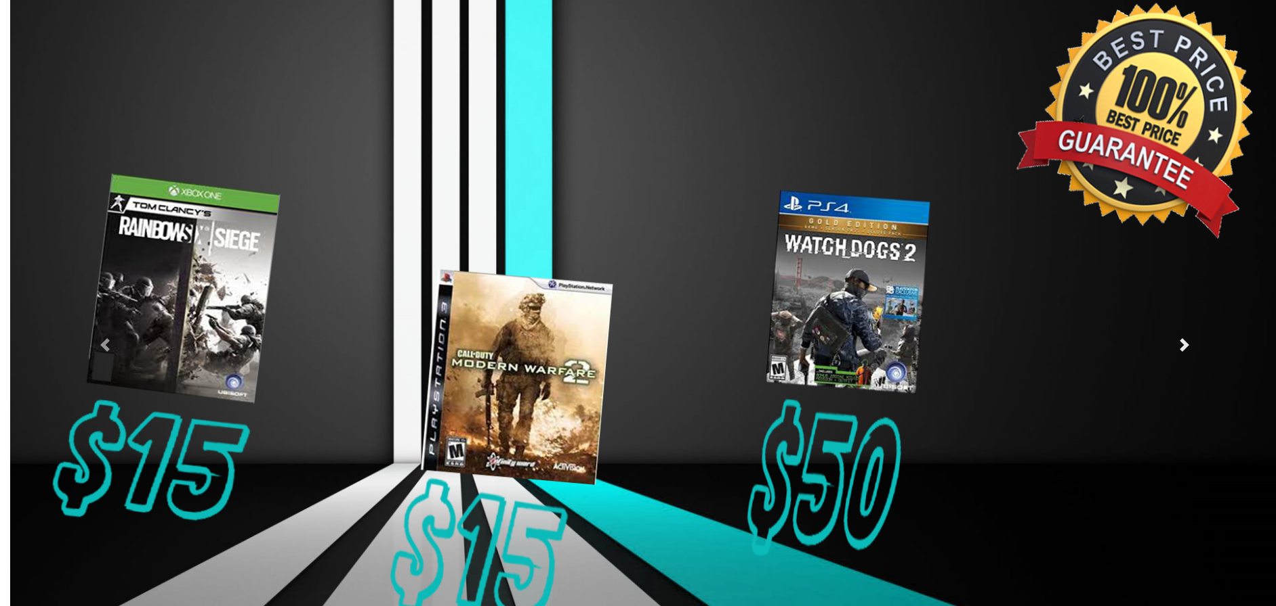***Portfolio***

***Content page:***

* ***The design breif***
* ***Research the areas of inverstigation***
* ***Desgin sketches***
* ***Final conceopt desgin***
* ***Design changes***
* ***Evaluation***
* ***Bioliograhy***

***Design brief:***

The Flynn’s web site has been decreasing in money as the trend for accessing video games has moved away from arcades and to your home with the consoles and becoming more popular. The Atari and the commodore 64 have completely shut down with the popularity of the consoles. Flynn wants to give his business life again as the venue for selling new games and trading used games. Flynn wants you to design and create a website that communicates his new business and make the sales get back up.

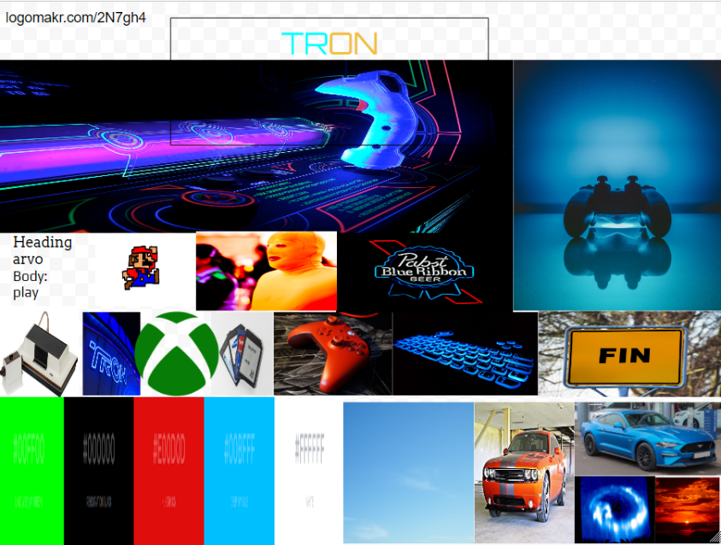

***Criteria of success:***

* ***A functioning navbar***
* ***A good set of sliders***
* ***Accessible Contact page***
* ***Product placing***
* ***A professional logo***
* ***Proper colour palette***

***Areas of investigation:***

CMS is a Full user ability that makes the websites work together with a database user friendly. There are lots of CMS options for websites such as WordPress, Drupal, Wix and Grid, and all of these CMS systems work differently allowing the website admin different levels of permission and control. Although the CMS is the entirety of the web claim database tables, CMS is typically judged on the functionality of its admin piece. WordPress is the most popular CMS because of its large plugin library, which rapidly increases its admin panel’s functionality.

Since launching in 2006, Wix has swiftly established itself as the market’s leading website. Before we get our into this review of Wix, though, let’s take a step back and explain what a website builder is Wix’s drag and drop editor makes it easy to create a professional website without having to know a line of code. With hundreds of templates and great tools Wix lets you build and sell through your site. Beginner friendly and scalable Wix is suitable for anything from personal online portfolios to small business websites.

Developers use many tools throughout software code creation building and testing. Development tools often include text editors, code libraries, compilers and test platforms. Without an ide a developer must select, deploy, integrate and manage all of these tools separately. An ide brings many of those development related tools together as a single framework, application or service. The integrated toolset is designed to simplify software development and can identify and minimize coding mistakes and typos. An ide typically contains a compiler or interpreter and a debugger accessed from one single gui. The compiler translates the source code into a readable language that is suited for a computer. The debugger tests the software to solve any issues or bugs.

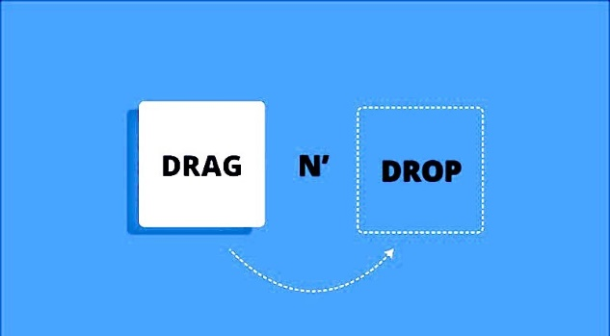Drag and drop has been with the editing community for years now. It helps us to get things done quicker on lots of stuff such as our desktops, mobile devises, apps and operating systems. There’s both a simplicity and instinct that has been led to it becoming one of the most universal features. There is a number of creative ways we can use the drag and drop and implement to our own designs. Some examples of drag and drop is JavaScript, HTML, CSS and BOOTSTRAP etc.

Note pad ++ is another way to edit and source code editor maintained by Microsoft windows. It supports tabbed editing which allows working with multiple open files in a single window. Notepad++ is a free software. At first the project was supported by SourceForge.net, from where it has been downloaded over 28 million times, and twice won the Source Forge Community Choice Award for Best Developer Tool. The project was on since 2015 Notepad++ has been hosted on GitHub. Notepad++ uses the Scintilla editor component.

***Flynn’s aesthetic:***

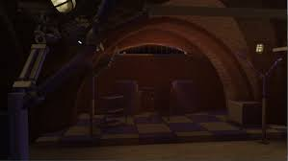The Flynn’s arcade is an old video game arcade that’s operated by Kevin Flynn. The arcade has a multi-story arcade with all classic games such as Donkey Kong, Mario kart 64, snake and packman etc. The first floor is all arcade games and the second floor is a trading floor to compete with other competitors that is more advanced than Flynn’s arcade. Flynn lived prior to taking control of the company ENCOM. The arcade has a secret entrance to the ground door which is from the basement.

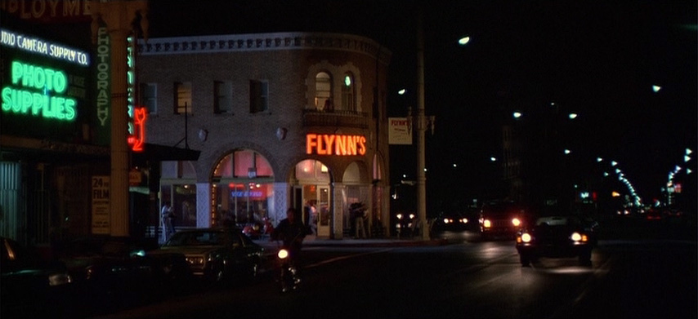The building used for the arcade was located in culver city, California and it is now known as “the hull of building” and it became the first hospital in California location that the arcade was on was on watseka st, which was later moved to mead st due to the lack of work that was coming in. the new area they moved were a lot better in every way, the streets always had movement every night and lots of entertainment. At one point in time the arcade was a chill place to hang out.

There were lots of different aesthetics about the arcade one of the most memorable is the fact that the front of the entrance “Flynn’s” sign is still lighting up bright and not damaged .The inside of the arcade has lots of space so the machines are shaped in a circle and in the middle are most popular arcade games. The arcade isn’t as lit up so the room feel and looks more mysterious, secretive and modern.

***Data communication:***

Data communications is the process of using computers and communication technologies to handover data from one place to another instantly, and the other way around. It enables the movement of electrical or digital data between two or more knobs, regardless of physical location, technical average or data contents.

Data communication incorporates several techniques and technologies with the primary objective of enabling any form of electronic communication. These technologies include telecommunications, computer networking and radio and satellite communication. Data communication usually requires existing of a transportation or communication medium between the nodes wanting to communicate with each other, such as copper wire, fibre optic cables and singles.

A common example of a data communications is a computer connected to the internet a transmission of communication.

***Design Sketches:***

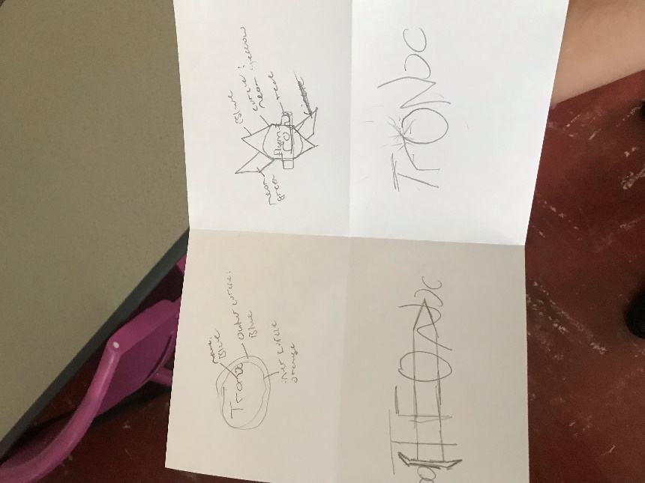Here I have my four design sketches, the third and fourth design were not aesthetically pleasing because of the way that the patterns and shapes did not match with the theme of Tron Legacy.

The first concept design is simple and suits with the Tron legacy as it had neon lights and was based off of the disc that they used in the movie. The name Tron has a neon blue colour as it ties in with the theme.

My second concept is more confusing as it has more details more shapes the design has most of the neon colours are there such as neon green, blue, yellow and red. I tried to make it in logo maker and I got negative feedback from my peers. The more detail I put into it, the more messy it looked.

At first I really liked having a sword in the Tron logo but the entire movie didn’t include a sword. I also made this logo in logo maker with all detail but at the end I decided to scrap it and move on to another design.

My last concept design was completely scraped I didn’t even go on logo maker it was just an idea I drew but never completed it.

***Final concept deign:***

This is my final concept with two snips of my top and bottom of the website.

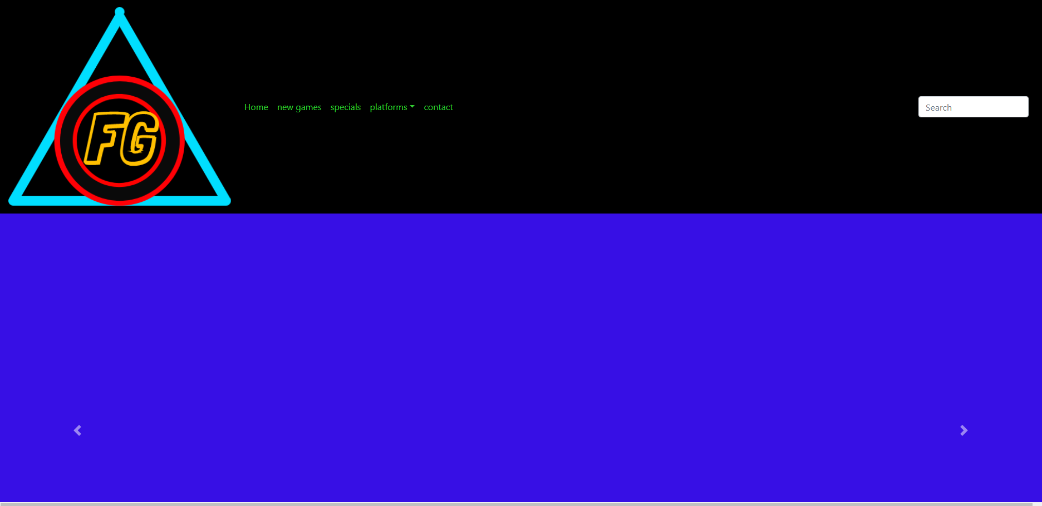

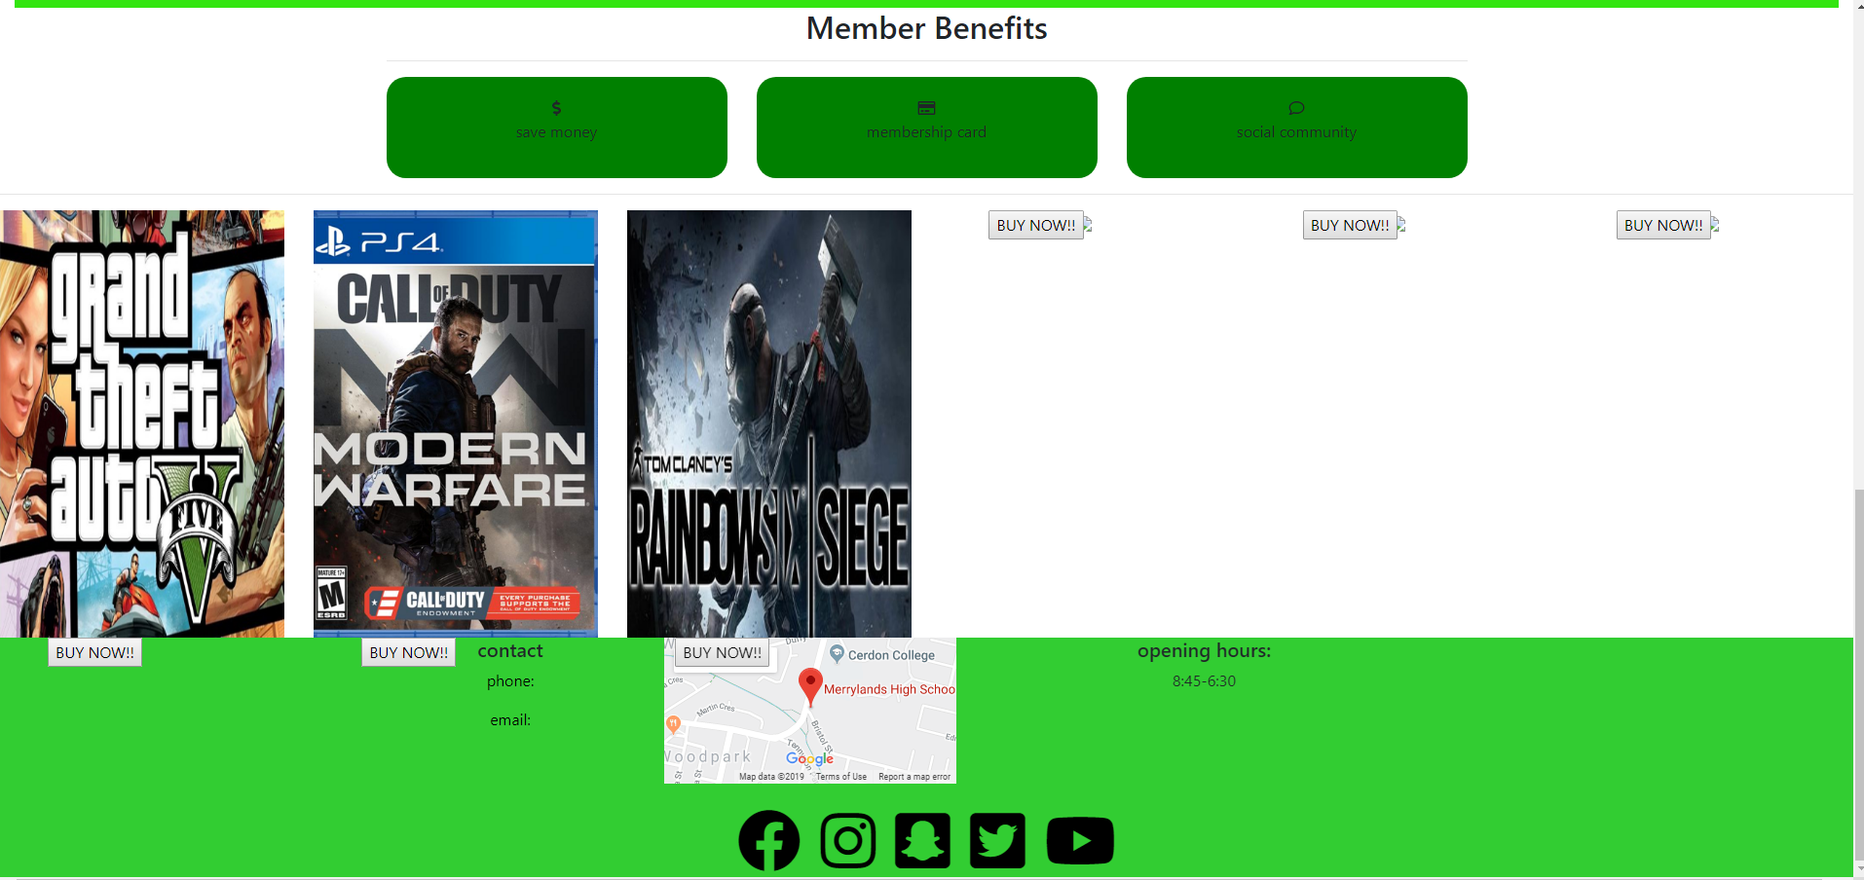

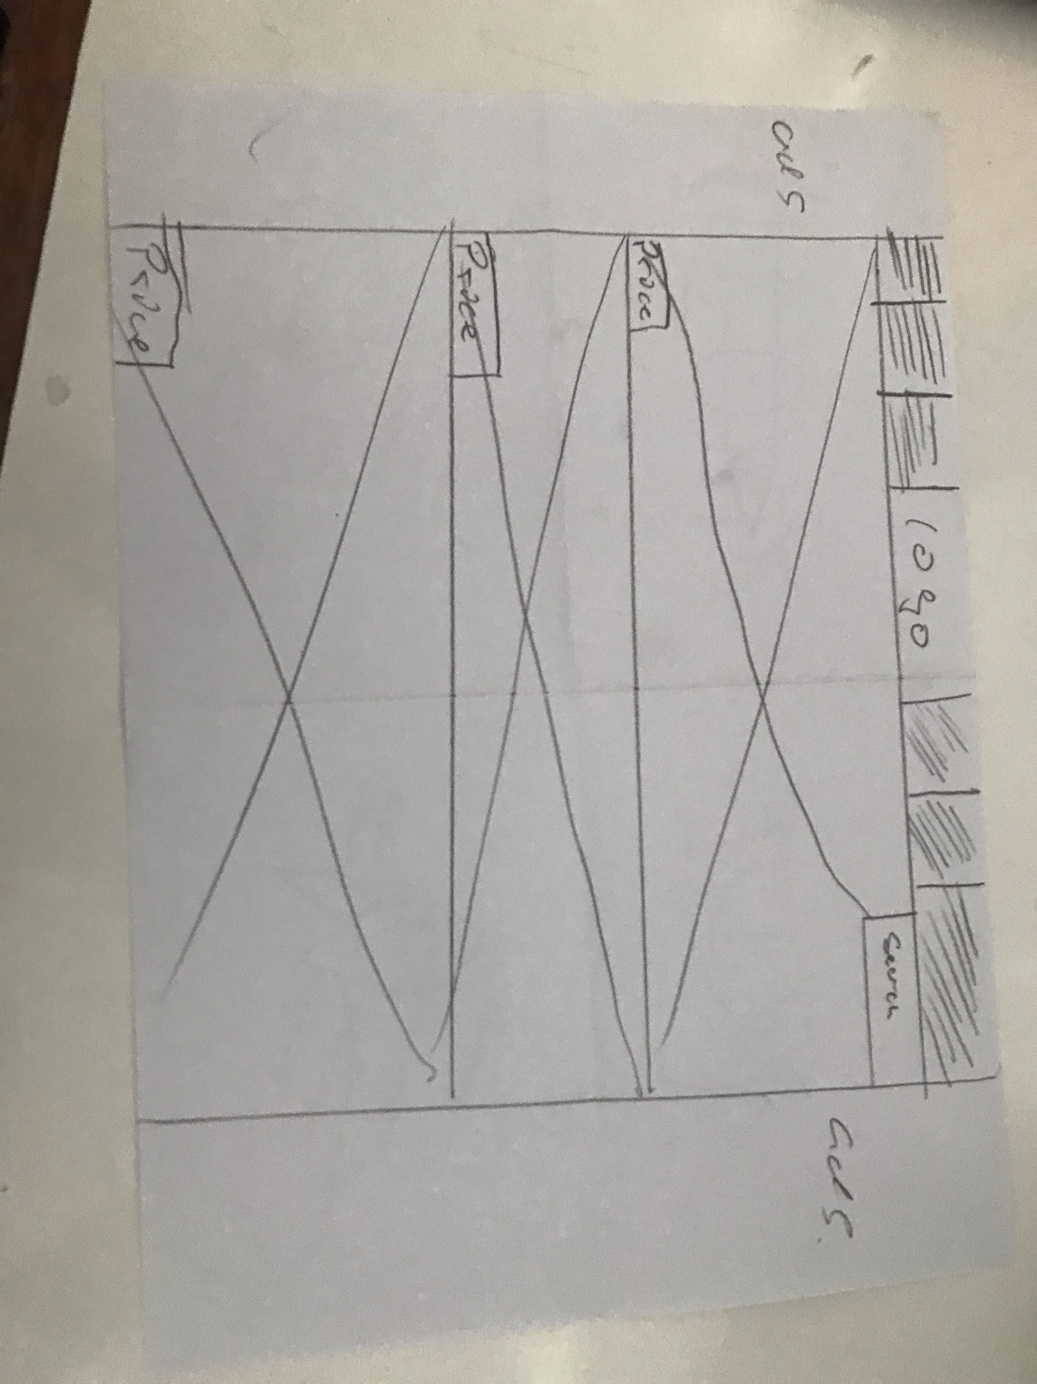

***Design changes:***

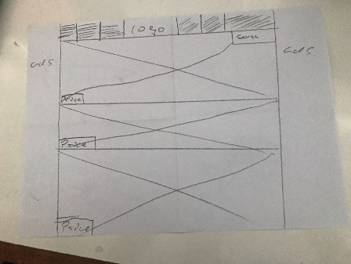My final concept design and my and final product has no similarity because of the lack of skill I have. I had a perfect idea on paper it has everything a website needs such as the logo in the middle, the drop downs, the search bar, the prices in the sliders and the advertisements on both sides of the website. My final concept design also had lots different menus that would take you to the right place such as if you needed to buy a new console it would take you to the destination with a very good bundle that you shouldn’t miss. The sliders was going to have three pictures each the first one was going to have the bundles, the second was going to have games and the third was going to be consoles.

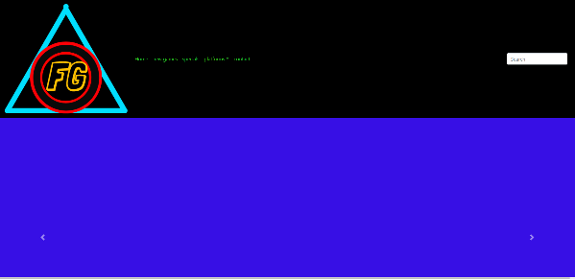My final product has most of the idea but not in the right positions. I only have one slider that is to big so when my sliders change it goes larger in size. The logo is in the middle is on the left and I only have three to four drop down menu. There was no advertisements on either side

***Evaluation:***

My website has lots of different features some I am proud of and most not as much. My website has lots of some problems I am not able to fix because I don't know how to and other problems like the lower footer and the top footer I am able to get around because I am used to getting stuck am now I can get around that but something like the slider or the membership things are very hard to work around because I never worked with that. I researched some good ways to make a good looking website it didn't really work out now it looks like an off brand website and the sliders look like a scam.

 The good things about my website is it stand out from the rest, it has a good colour palate it is nice and simple with difficult code inside my website. If it was finished this website will actually look alright with more things that would be in my website such as the sliders there were other options for better looking sliders but that would be taking too long so I had to choose something more simple but that was also one aim for my website which was to slick that’s why I went for a green and black colour palate those two colours work together to make a good smoothness feeling.

My website needs a little bit of everything actually but mostly improvements form little bugs too big as the changing different pages when clicked on. Other improvements that I need is finishing the two other sliders and redesigning the first slider to make it less scam looking like and change the positioning of the sliders. The membership doesn't look like what i wanted its small, not the same green i use and another positioning problem I would like that all three

***Bibliography:***

* [***http://tron.wikia.com/wiki/Flynn&#39;s_Arcade***](http://tron.wikia.com/wiki/Flynn&#39;s_Arcade)***)***
* [***https://www.jbhifi.com.au/***](https://www.jbhifi.com.au/)
* [***https://www.ebgames.com.au/***](https://www.ebgames.com.au/)
* [***www.techopedia.com***](http://www.techopedia.com)
* [***https://notepad-plus-plus.org/***](https://notepad-plus-plus.org/)
* [***https://searchsoftwarequality.techtarget.com/definition/integrated-development-environment***](https://searchsoftwarequality.techtarget.com/definition/integrated-development-environment)
* [***https://360ideas.com/blog-web-design-how-does-a-cms-content-management-system-work/***](https://360ideas.com/blog-web-design-how-does-a-cms-content-management-system-work/)